

PROMO SHEET – EP

“BEYOND”  
  
  
  
Self-Released – Now Available

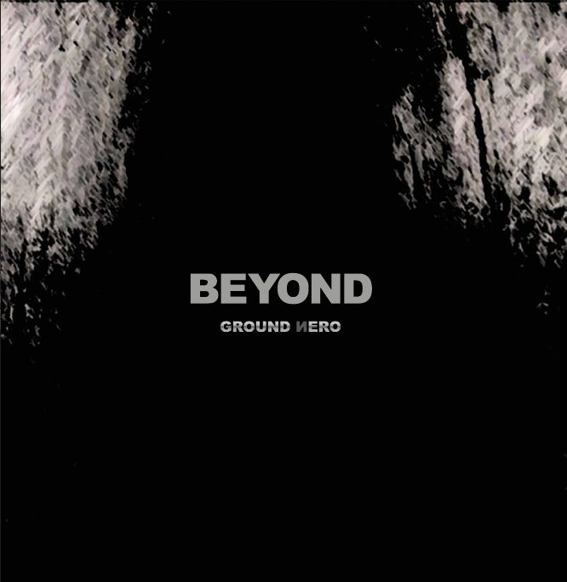

**GROUND NERO is the new Belgian dark wave/gothic band that redefines 80ies post punk & cold wave sound, making use of state-of-the art sound tech but keeping cold wave roots and culture, re-staging it with multi-layered “wall-of-sound” arrangements, aiming at making people shiver….**

**THE SOUND:  
Heavy guitars, making use of typical 80ies sound effects, combined with dark synths and multi-track drums, forming a massive nero ground to accentuate the powerful voice of Guido Wampers, AKA Gwijde de Eerste.**

**MEMBERS:**

**Gwijde De Eerste:** Vocals

**Peter Philtjens:** Bass

**Peter Smeets:** Guitars / Synths

**Danny Quetin:** Sound Engineering

**GROUND NERO is inspired by iconic bands, such as Joy Division, Sisters of Mercy, Killing Joke, The Dance Society, The Chameleons, Cocteau Twins, X-Mal Deutschland, The Sound, Wire….**

**With the first only vinyl EP “BEYOND” you will find the dark dimensions of what GROUND NERO stands for. They have chosen to release this EP by themselves, controlling all aspects from the beginning till the end.**

**Find more about GROUND NERO under:**

[**http://www.facebook.com/Groundnero/**](http://www.facebook.com/Groundnero/) **or listen and buy BEYOND at their bandcamp page:**

**The “BEYOND”-EP will be presented at November 10th at Les Vierges Morbides at “El Diablo”, Lille-France and at November 26th at KC Belgie – Hasselt.**

**Shiver & Shake!**

**Hospitality**

**Dressing Room**

Organiser / Promoter will provide one large and comfortable dressing room at the sole disposition of the group with table, chairs and mirror and 4 x 220V power outlet for laptops / cell phones. The key to this dressing room shall be handed to the group’s representative on arrival.

**Catering**

After the show, a light meal for 4 people will be provided.

Before & after the show:

* mineral water
* Beers
* White wine
* Coke zero
* Coffee (with milk & sugar)

**Merchandise**

One table and one 220V power outlet is required.

If the organiser sells all artist merchandising through their own concessions, please supply information such as contact name and details, conditions of sale, commission and details on delivery of stock.

**Accommodation**

If applicable, the organiser will reserve 4 bedrooms each with private bathroom in a good quality hotel near the venue. Promoter has to provide safe and free parking at or near the hotel.